9/12/2024

CMS ID: 023-23-0365

dsa LAB 04 || SUBMITTED TO MA’AM MARINA GUL

LAB O4 Exercise

Faheem Akbar

1. Stack using array: Understand provided code and implement all required methods in Stack. Stack Code is given below:

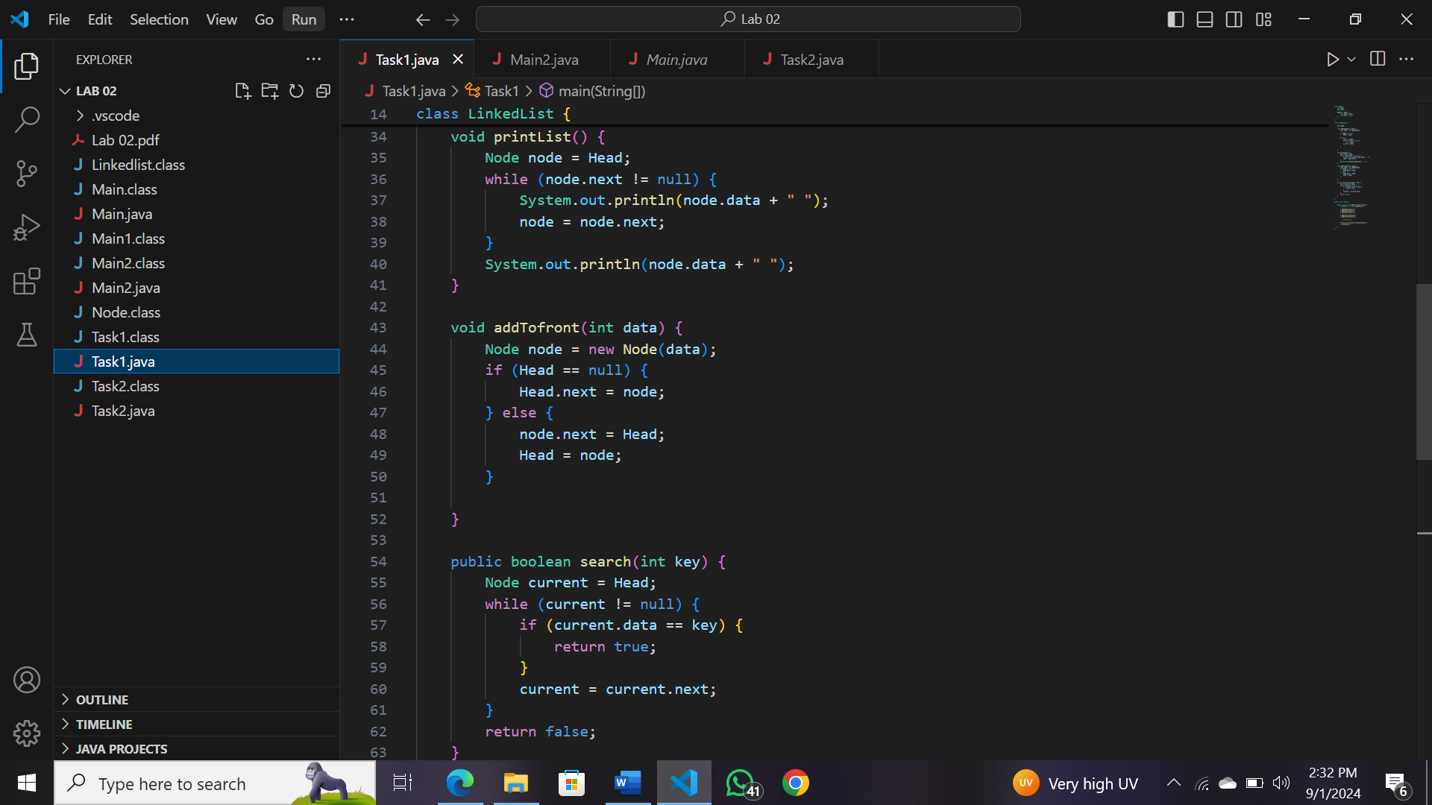

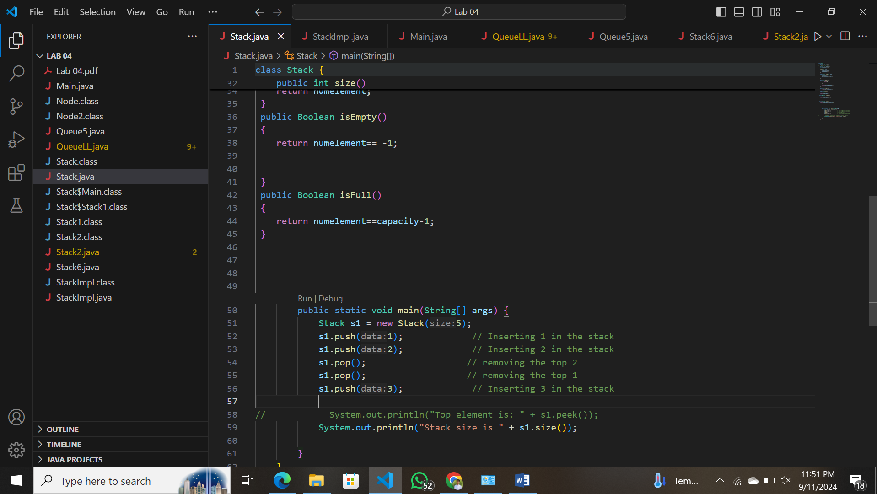

OUTPUT 1:

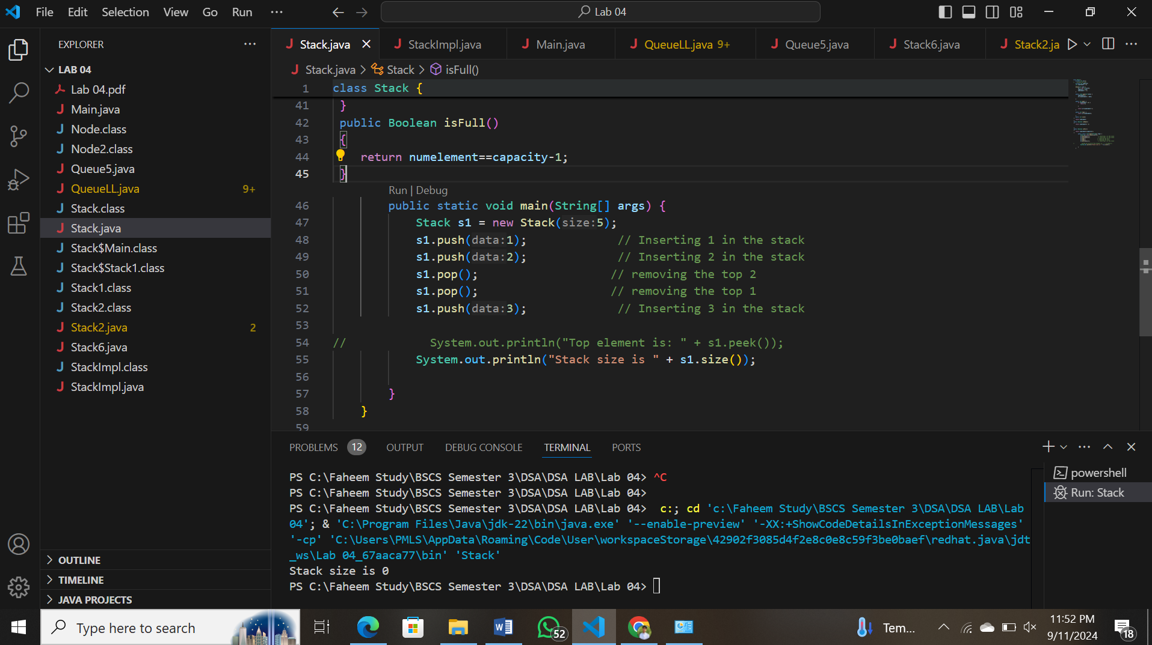

1. 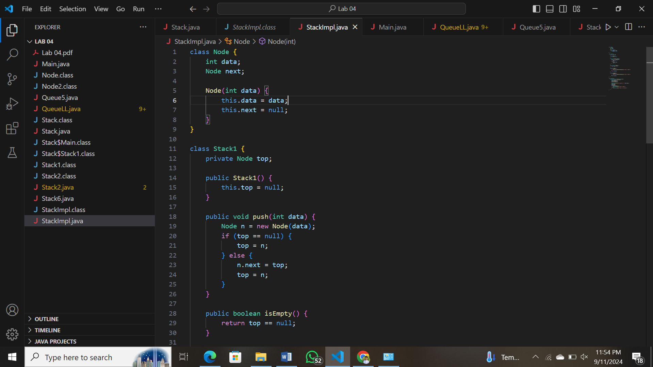Stack using Linked list: Understand provided code and implement all required methods in Stack. Stack Code is given below:

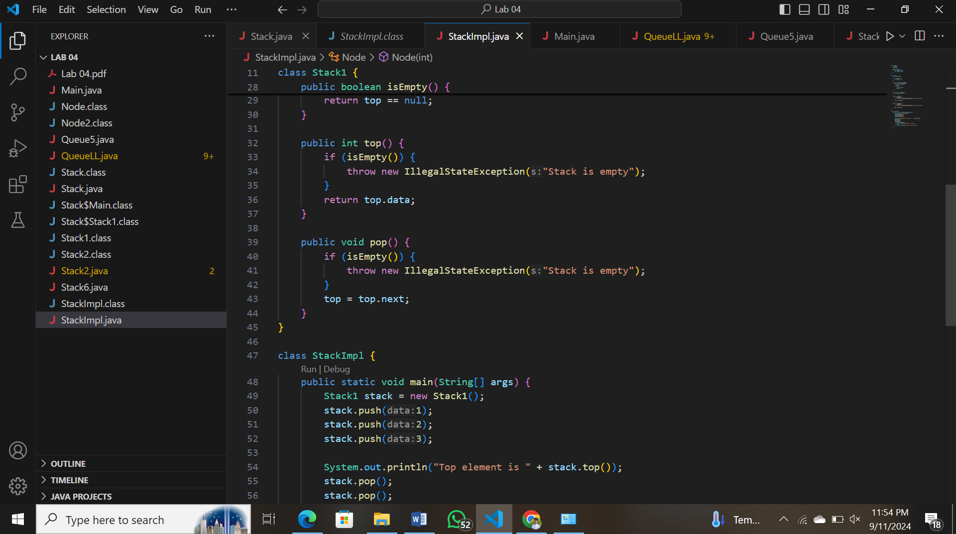

OUTPUT 2:

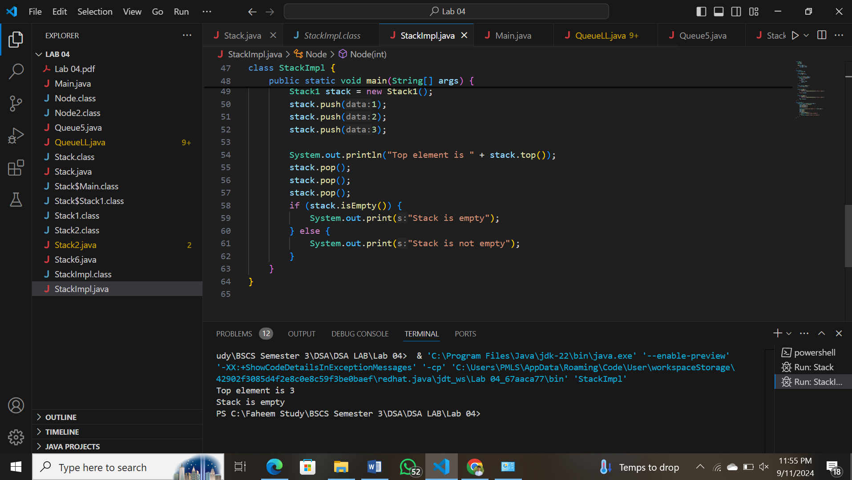

3: Queue using array: Understand provided code and implement all required methods in Queue. Queue Code is given below:

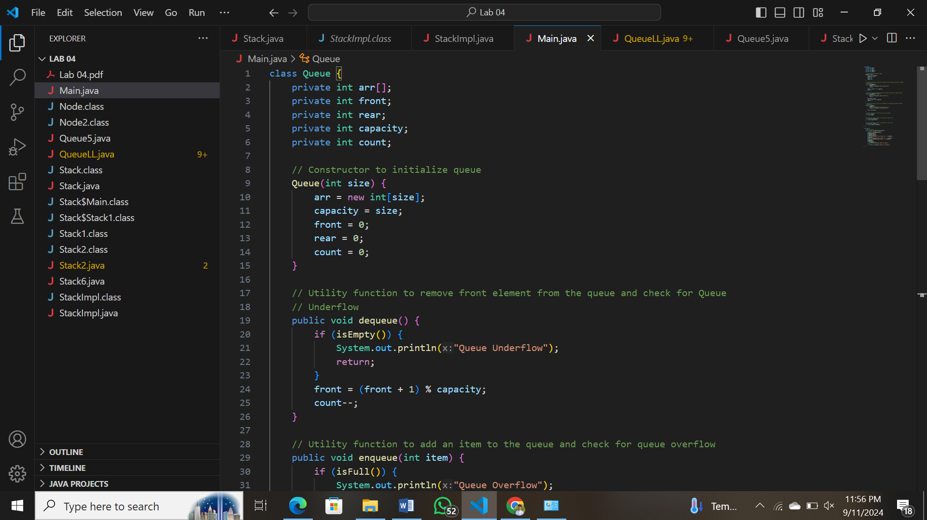

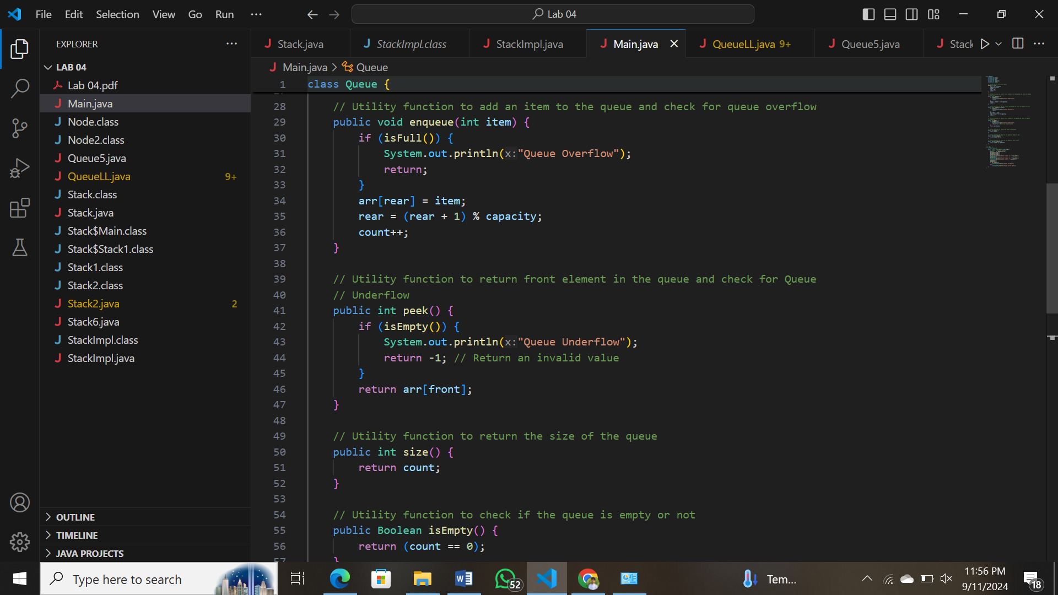

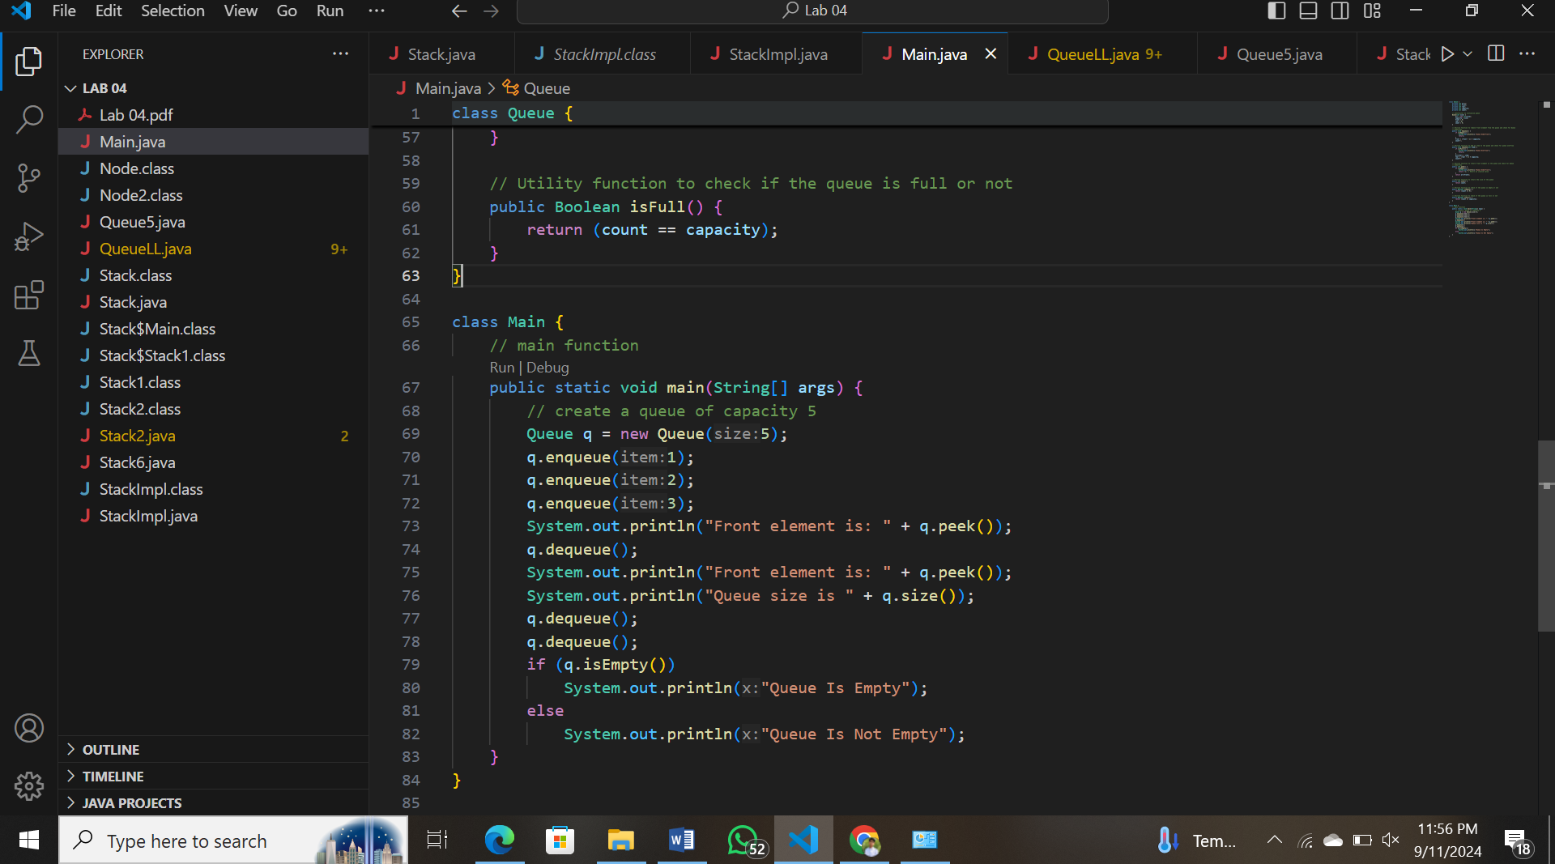

OUTPUT 3:  
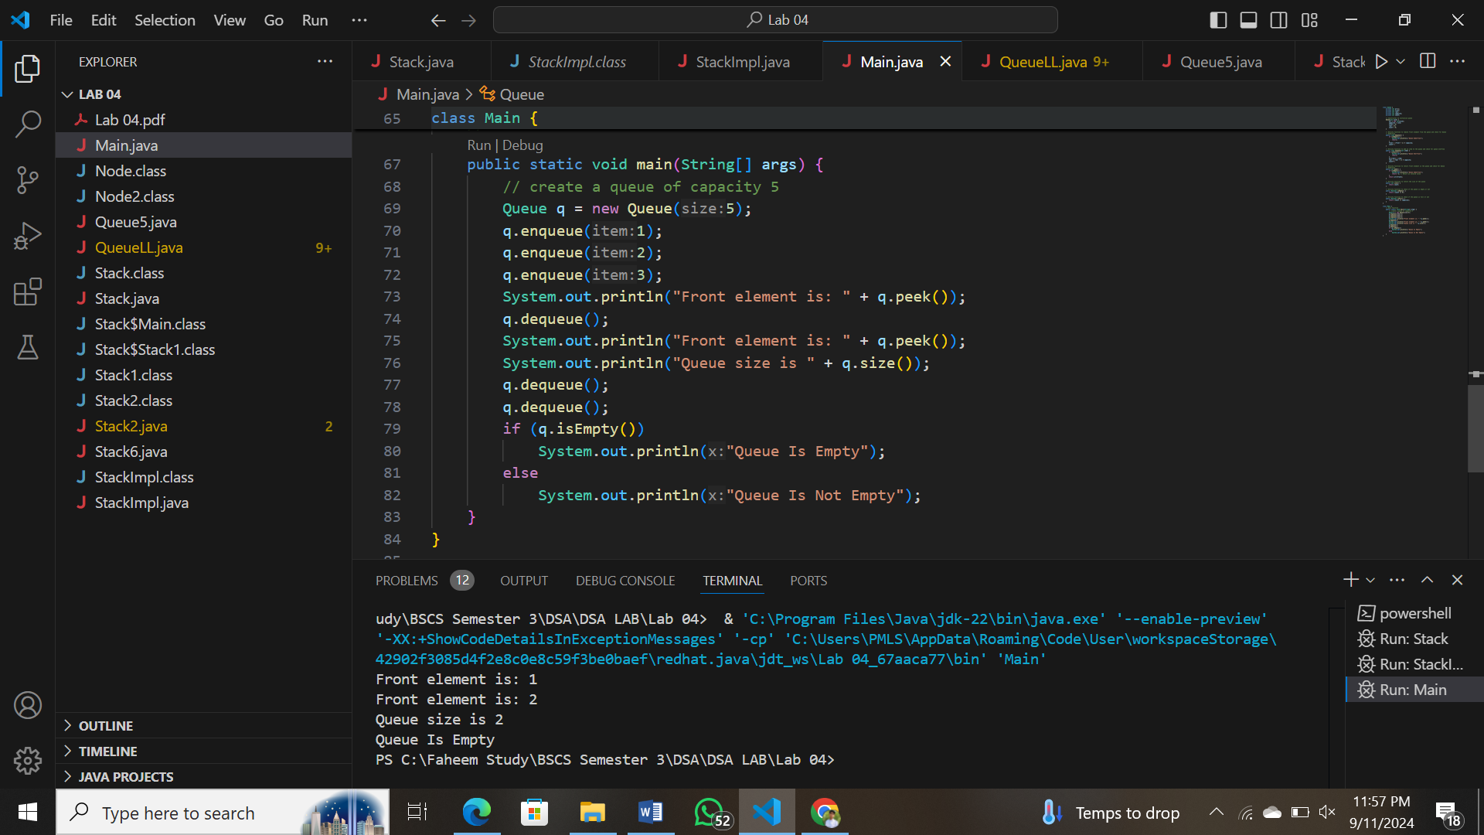

4. Queue using Linked list: Understand provided code and implement all required methods in Queue. Queue Code is given below:

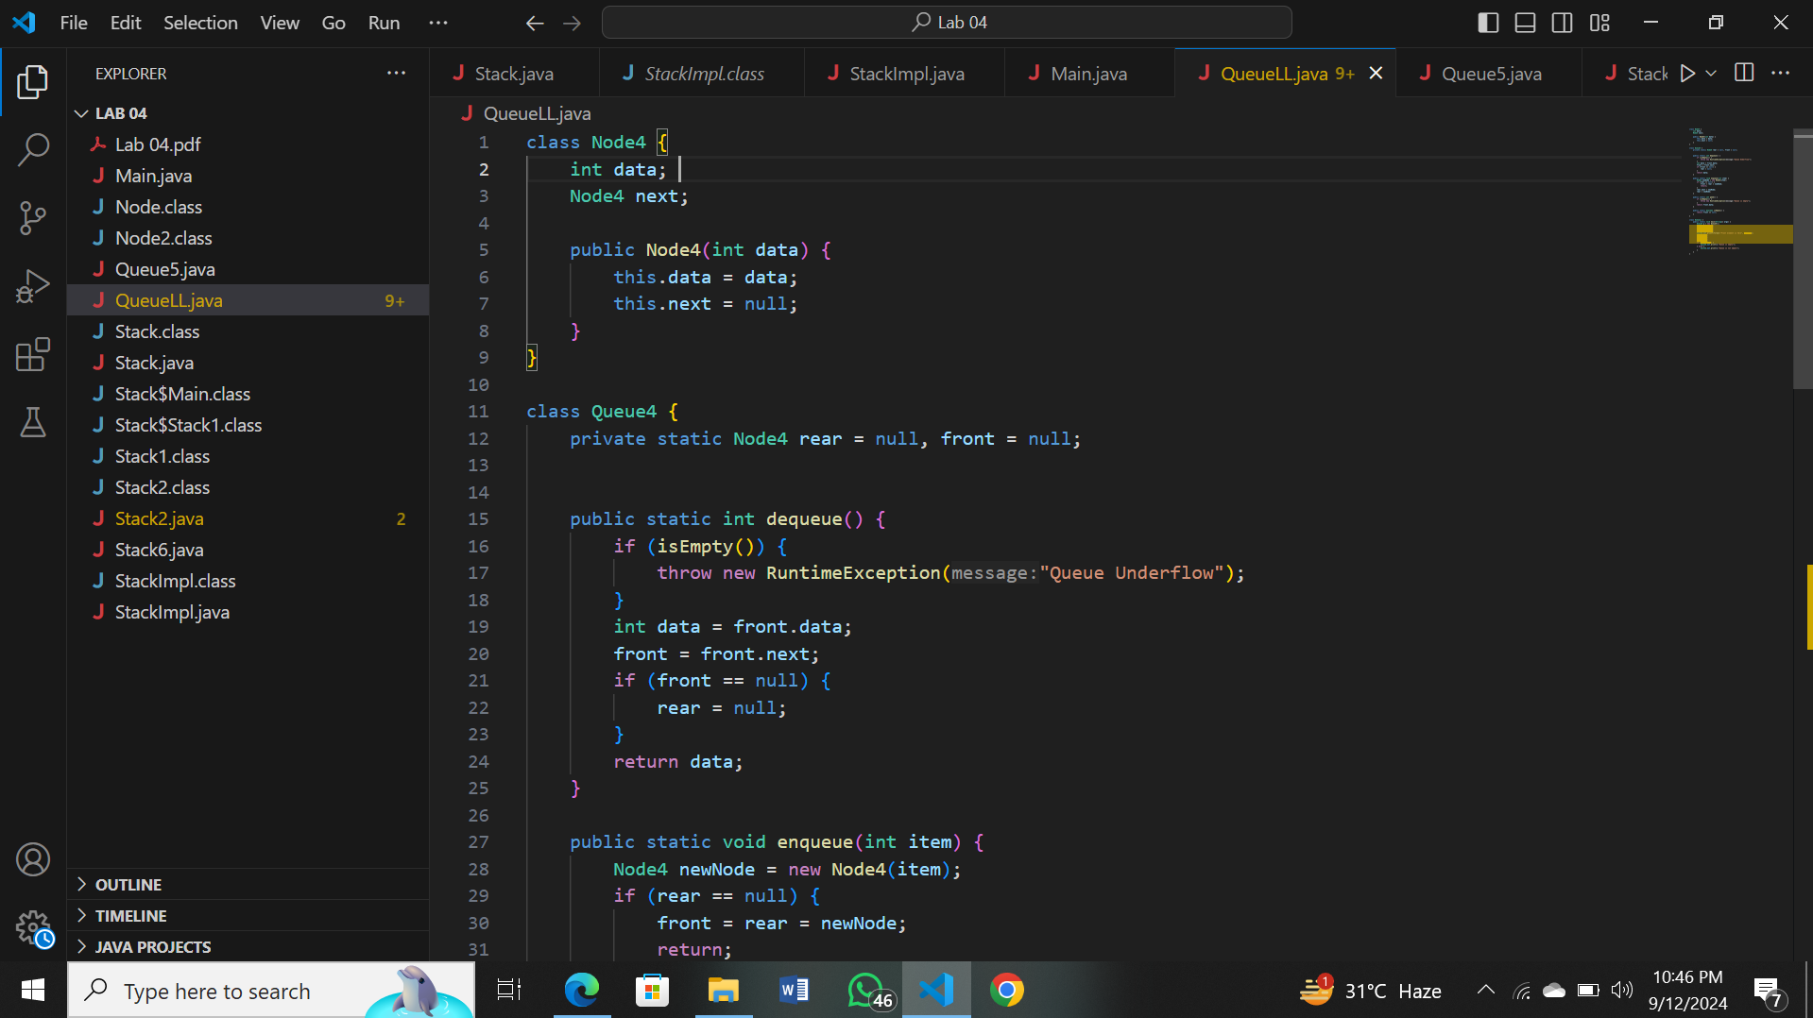

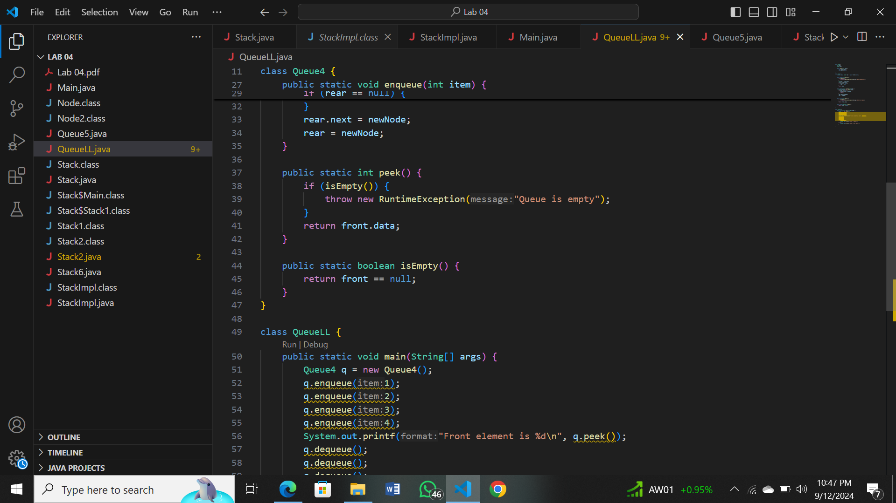

OUTPUT 4:

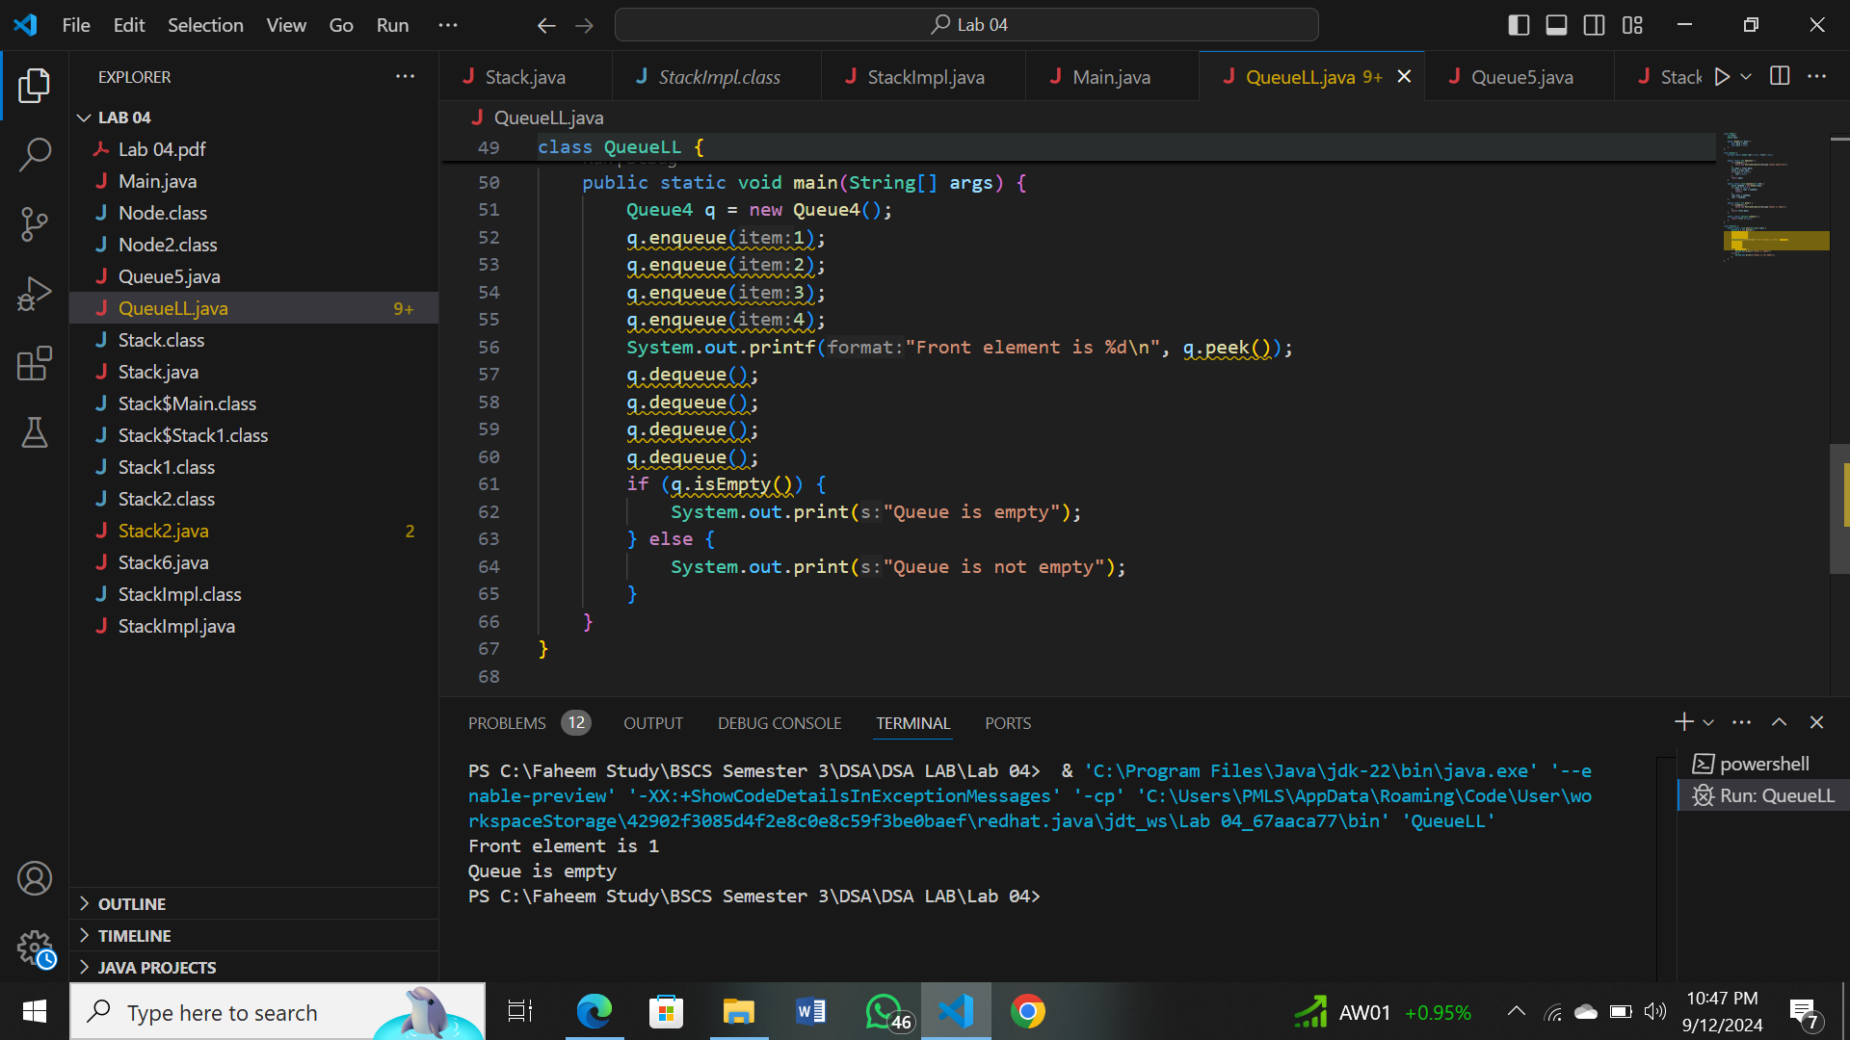

5. Queue using two Stacks: Understand provided code and implement all required methods in Queue Class. Sample Code is given below:  
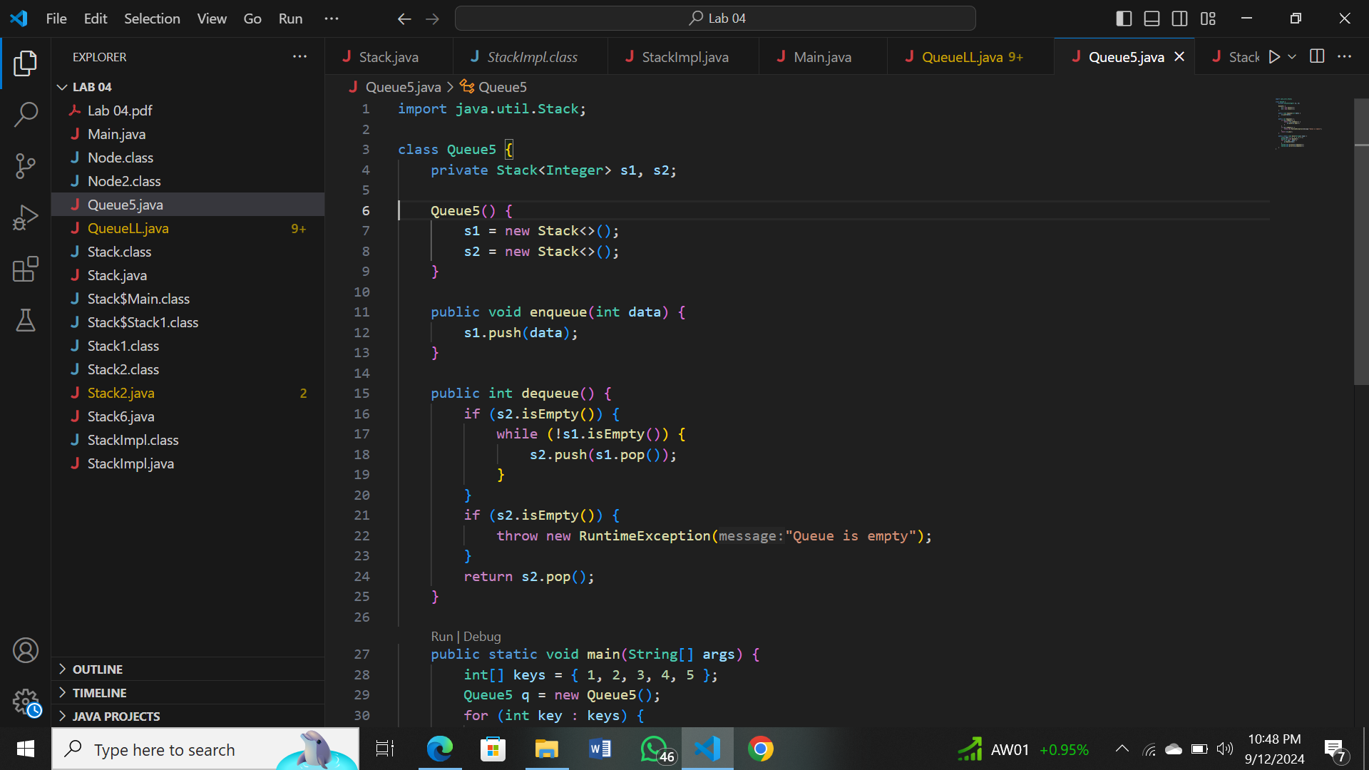

OUTPUT:

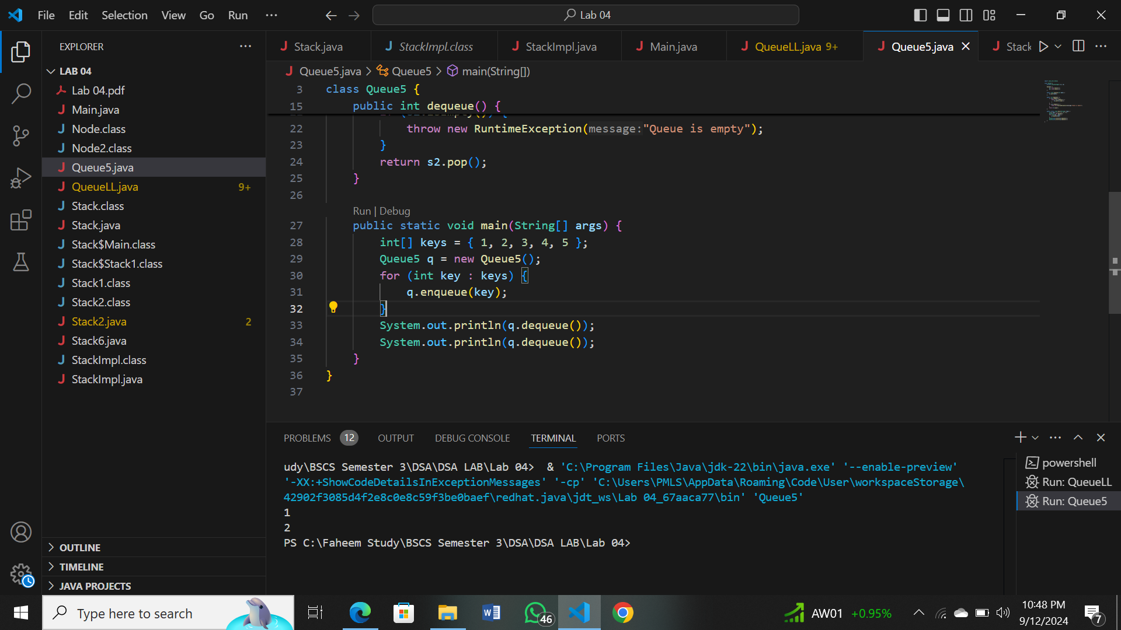

6. Think about the inverse of task 05 (Stack using queue) and implement all the required methods.  
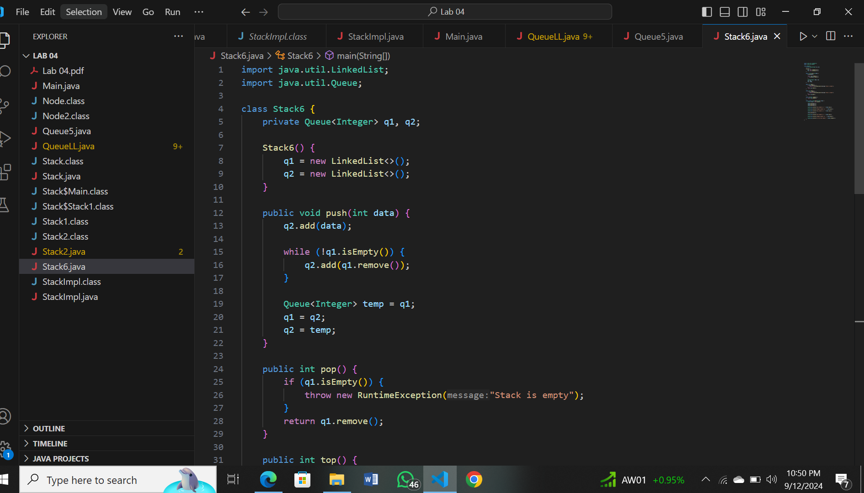

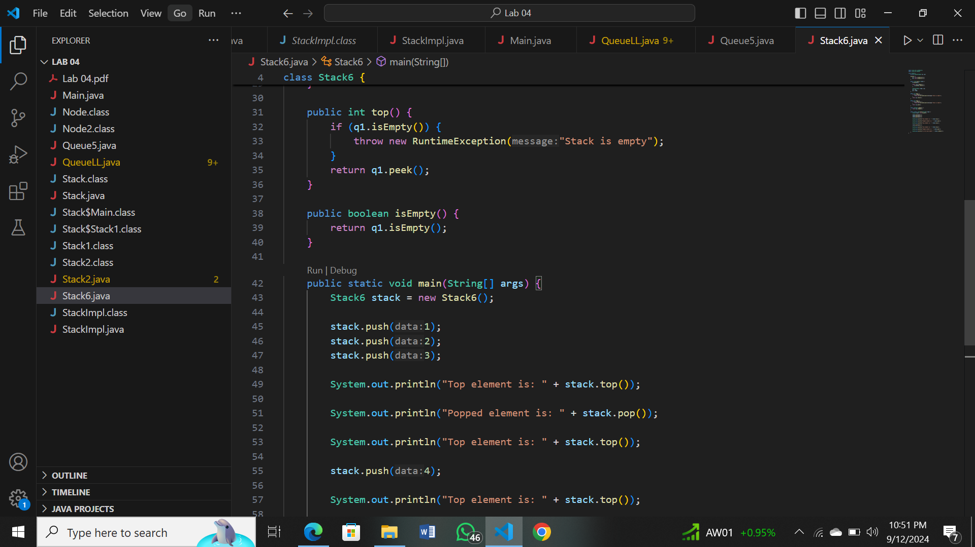

OUTPUT 6:

